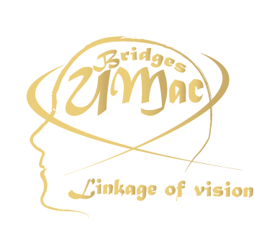 |  | 

UMAC BRIDGES 2007®
ALL RIGHTS RESERVED
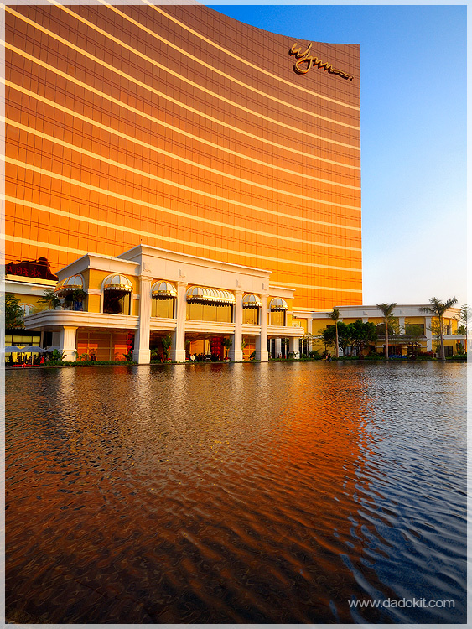
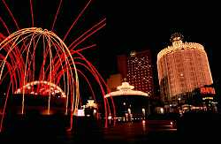
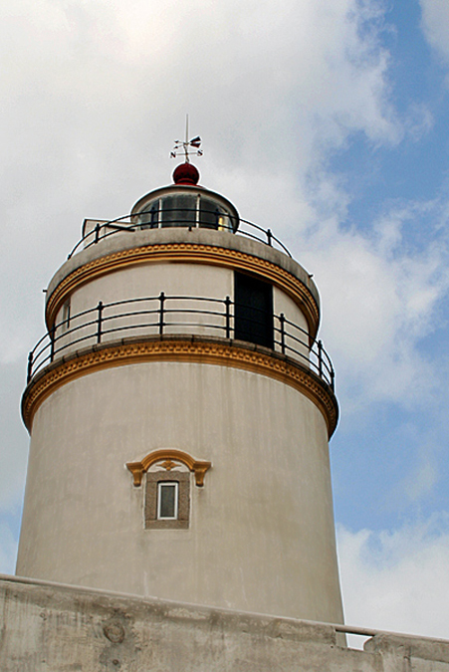
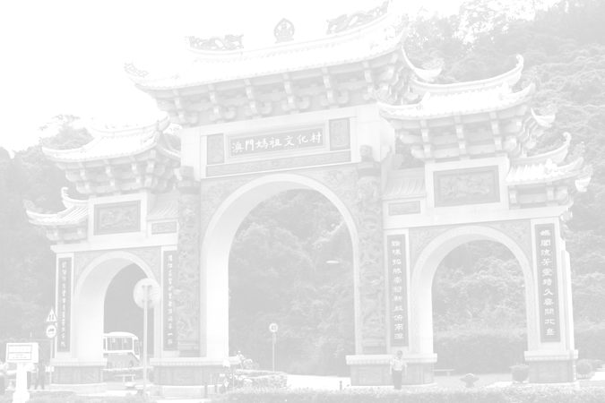
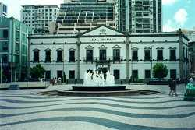
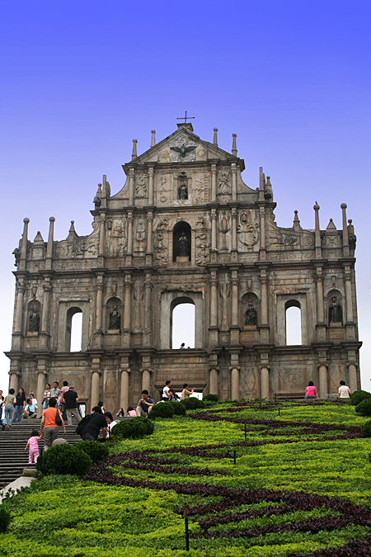

UMAC BRIDGES
“黃金時代最具代表性的建築物”攝影比賽章程
- 目的：令澳門大學教職務員可參與本雜誌的制作。透過是次攝影比賽，可令參實者更了解本澳的事物，帶動學生對本澳事物的興趣。

(二) 參賽辦法：
內容：凡以2006-2007年澳門具有代表性的建築物為主題的作品均可參加。
參賽資格：所有對攝影有興趣的教職員者均可參加。
相片要求：菲林相機或數碼相機作品，黑白及彩色均可。
規格：作品大小為4R(400萬像或以上)，必須用黑框裝裱。
參賽作品數量：每位參賽者只限最多兩項作品
參賽作品識別：參賽者須於作品背面寫上編號、員工編號、作品題名、作者姓名、通訊地址及聯絡電話。

(三) 截件日期：2007年4月23日 (星期一)

(四) 收件地點：何賢會議中心門口

(五) 評選委員：由主辦單位將邀請有關專業人士擔任。
(六) 結果公佈：2007年5月於UMAC BRIDGES 發佈會當日。得獎者將獲得專函及電話通知。
(七) 獎項：
分為冠亞季軍及最具創意大獎。所有得獎者將有獎狀一張。其得獎作品將會印刷在UMAC BRIDGES 內。
(八)查詢：邵小組/譚小姐/簡小姐
電話: 66330046 / 66510606 / 66625490
電子郵箱：umacbridges@gmail.com

*章程如未盡善之處，主辦單位有權修改*
Regulations for the UMAC BRIGES －
“Golden Era – The Most Representative Building” Photo Competition
1. Objectives: Our aim is to encourage UMAC staffs to participate in the production of our UMAC BRIDGES. Through this competition, participants could have better understanding of Macau, and to drive students in knowing more about Macau.
2. Requirements:
Content: Any works capturing Macau’s most representative buildings will be accepted.
Eligible Participants: All staffs and professors who are interested are welcomezd1
Photo Requirements: All kinds of works, black & white or color, taken by film camera or digital camera.
Photo Size: 4R (4.0 mega pixels or above). Each photo must be framed on a black cardboard paper
Maximum submission per person: Maximum to 2 photos for each participant.
Participant Identification: A participant must provide the photo number, staff number and topic of his/her work, his/her name, address and contact number(s) on the reverse.

3. Submission Deadline: April 23rd 2007 (Monday)
4. Receiving Address: In front of Ho Yin Convention Center
5. Judging Panel: The panel members will be experts invited by the Organizer.
6. Result Announcement: May 2007, the publication day of UMAC BRIDGES. All winners will be informed individually

7. Prizes:
All winners will receive a certificate and the photos of will be published in the UMAC BRIDGES

8. Enquiry: Mina Siew / Sharon Tam / Rossetti Kan
Tel.: 66330046 / 66510606 / 66625490
E-mail: umacbridges@gmail.com

